BAN 610 Problem set 2 - SQL

Edit your submission in this word document, attaching the screenshots of the codes used for each question. Include narrative descriptions, outputs screenshot, or short answers when requested.

**Task 1**

Use the frequent flyer database.

List all flights (Flight_no) for those that leaves HOU or SFO

**Query:**

select *

from(

select

Flight_no

from flight

where Flight_Origin in('HOU','SFO')

) a

where Flight_no is not null;

**Output:**

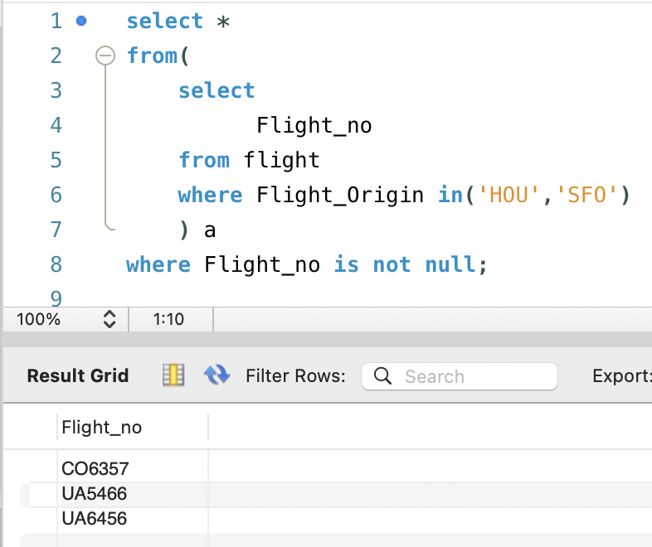

**Task 2**

Use the frequent flyer database.

Generate a list of all information about the frequently flyer whose **first name** starts with “D”.

**Query:**

select *

from(

select *

from flyer

where Flyer_Name like '%, D.'

) a

where Flyer_Name is not null;

**Output:**

**Task 3**

Use the frequent flyer database.

Generate a list of all flight operators, along with the number of flights of each operator, and its average miles per flight. Order the output by the average miles per flight in descending order.

**Query:**

select Flight_operator,

count(Flight_operator) as Number_of_flights,

sum(Miles_per_flight) / count(Flight_operator) as Average_miles_per_flight

from flight

group by Flight_operator

order by Average_miles_per_flight desc;

**Output:**

**Task 4**

Use the frequent flyer database.

For each Flight_operator, calculate the number of trips commissioned by it with a fare greater than $300.

**Query:**

select Flight_operator,

count(Flight_fare) as Trips_greater_than_300

from flight

join trip

on flight.Flight_no = trip.Flight_no

where Flight_fare > 300

group by Flight_operator;

**Output:**

**Task 5**

Use the frequent flyer database.

List the names of the flyers who ever went to Atlanta

**Query:**

select Flyer_Name

from flyer

join trip

on flyer.Frequent_Flyer_ID = trip.Frequent_Flyer_ID

join flight

on trip.Flight_no = flight.Flight_no

where Flight_Destination = 'ATL';

**Output:**

**Task 6**

Use the frequent flyer database.

Identify all the possible round trips from the flight table (e.g., there is an A to B trip and a B to A trip available). List the Flight_no, the origin, and the destination. Your result should look like the following:

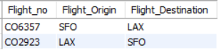

**Query:**

select f1.Flight_no,

f1.Flight_Origin,

f1.Flight_Destination

from flight f1

join flight f2

on f1.Flight_Origin = f2.Flight_Destination

and f1.Flight_Destination = f2.Flight_Origin;

**Output:**

**Task 7**

Use the frequent flyer database.

What is the most visited flight destination?

In case of a tie, list all of them.

**Query:**

select

Flight_destination

,count(*) as No_of_Times_Visited

from flight a

group by Flight_destination

having No_of_Times_Visited=( select max(No_of_Times_Visited)

from (

select

Flight_destination

,count(*) as No_of_Times_Visited

from flight a

group by Flight_destination

)a

);

**Output:**

**Task 8**

Use the book loan database.

Extract the most popular author in the university (borrowed the most often by students)

In case of a tie, list all of them.

**Query:**

select

Book_First_Author

,count(*) No_of_Times_Borrowed

from book

join copy

on book.Book_ISBN = copy.Book_ISBN

join loan

on copy.Book_Call_No = loan.Book_Call_No

group by Book_First_Author

having No_of_Times_Borrowed = ( select max(No_of_Times_Borrowed)

from (

select

Book_First_Author

,count(*) No_of_Times_Borrowed

from book

join copy

on book.Book_ISBN = copy.Book_ISBN

join loan

on copy.Book_Call_No = loan.Book_Call_No

group by Book_First_Author

)a

);

**Output:**

**Task 9**

Use the book loan database.

Use the loan table, for each student, calculate the total payment due for all books he/she borrowed. Assume that the university charges $0.1 per book per day for book loans.

**Query:**

select

student.Stu_ID,

student.Stu_Name,

sum(datediff(loan.Due_Date,loan.Borrow_Date) * 0.1) as Payment_Due

from student

join loan

on student.Stu_ID = loan.Stu_ID

group by student.Stu_ID,student.Stu_Name;

**Output:**

